Raw info

Employees:
Employee Number: 912
SIN: 444 555 666 | Employee Group Code: S
Name: Jason Readalot | Employee Group Name: Sales
Address: 4567 – 89 Ave NW

Books:
ISBN: | 0-7356-1374-5
Title: | How I fell in love with Normalization
Suggested Selling Price: | 48.00
Quantity On Hand: | 6
Publisher Code | Publisher Name
134 | Microsoft Press

Sales:

Sale Number | 3002 | Sale Date Jan 11, 2026
Customer | Bob Brown | Customer Number |  | 502
 | 12222 – 66 Street NW
 | Edmonton, AB
 | T5J 1X1
Employee | Jason Readalot | Employee Number |  | 912
ISBN | Book Title | Price | Quantity | Amount
0-7356-1374-5 | How I fell in love with Normalization | 40.00 | 1 | $40.00
0-8888-1234-5 | Normalization for Dummies | 30.00 | 2 | $60.00
0-1234-1234-6 | Case of the Missing Attributes | 145.00 | 1 | $145.00
 |  | Sub Total |  | $245.00
 |  | GST |  | $12.25
 |  | Total |  | $257.25

1NF
Employee:

employee_number (PK)
sin_number
full_name
home_address
group_code (FK)
group_name

Books:

isbn (PK)
title
suggested_price
qty_on_hand
publisher_code (FK)
publisher_name

Sales:
sale_number (PK)
isbn (PK)
sale_date
customer_number (FK)
customer_name
street_address
city_prov
postal_code
employee_number (FK)
quantity_sold
actual_price
2NF
Sales:

Table: Sales:
sale_number (PK)
sale_date
customer_number (FK)
customer_name
street_address
city_prov
postal_code
employee_number (FK)

Table: Sale_Items :
sale_number (PK, FK)
isbn (PK, FK)
quantity_sold
actual_price

3NF
Employees:
Table: Employees
employee_number (PK)
sin_number
full_name
home_address
group_code (FK)

Table: Employee_Groups
group_code (PK)
Group_name
Books:
Table: Books
isbn (PK)
title
suggested_price
qty_on_hand
publisher_code (FK)

Table: Publishers
publisher_code (PK)
publisher_name

Sales:
Table: Sales
sale_number (PK)
sale_date
customer_number (FK)
employee_number (FK)
gst_amount

Table: Customers
customer_number (PK)
customer_name
street_address
city_prov
postal_code

Table: Sale_Items
sale_number (PK, FK)
isbn (PK, FK)
quantity_sold
Actual_price

Code
Code execution:
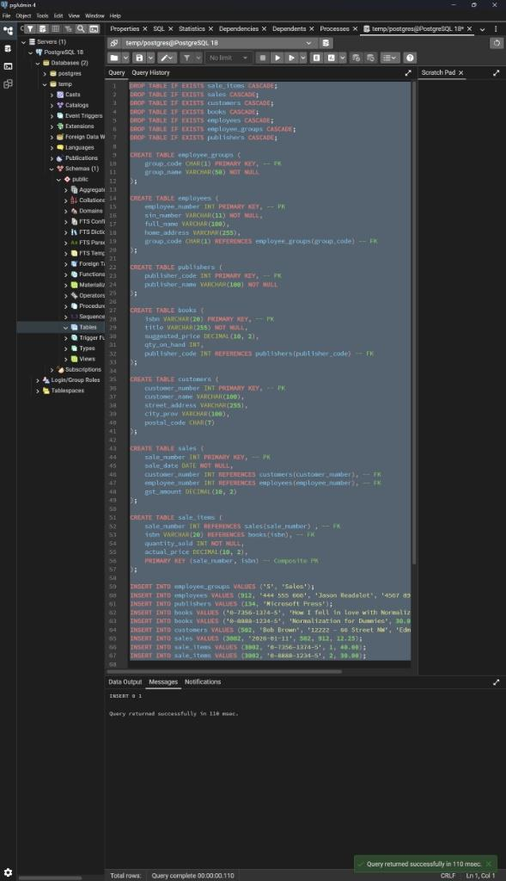

Final output:
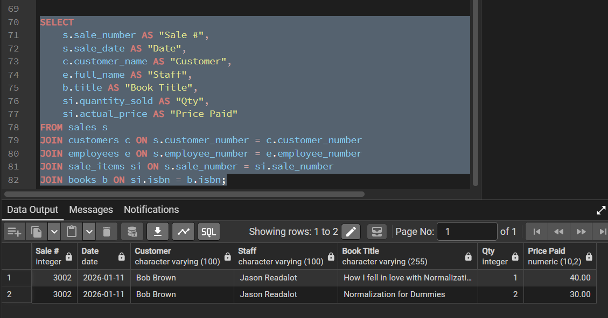

Merged ERD
